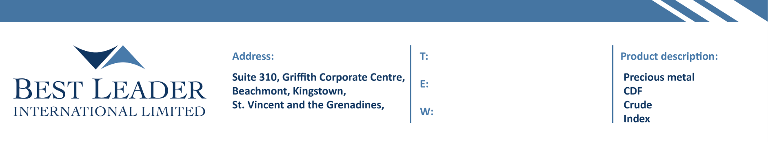

www.blintl.com

Best Leader International Limited
ANTI-MONEY LAUNDERING STATEMENT

Introduction

  - Best Leader International Limited (hereinafter referred to as the “Company”), is incorporated under the laws of Saint Vincent and the Grenadines with Registration 25515 BC 2019 having its registered office at Suite 310, Griffith Corporate Centre, Beachmont, Kingstown, St. Vincent and the Grenadines. The Company is authorised as an International Business Company under the International Business Companies (Amendment and Consolidation) Act, Chapter 149 of the Revised Laws of Saint Vincent and Grenadines, 2009 (herein the “Law”).
  - The objects of the Company are all subject matters not forbidden by International Business Companies (Amendment and Consolidation) Act, Chapter 149 of the Revised Laws of Saint Vincent and the Grenadines, 2009, in particular but not exclusively all commercial, financial, lending, borrowing, trading, service activities and the participation in other enterprises as well as to provide brokerage, training and managed account services in currencies, commodities, indexes, CFDs and leveraged financial instruments.
  - The Company is committed to combating money laundering and for this reason it has appointed a dedicated Anti-Money Laundering Compliance Officer (the “AMLCO”) who is accountable to the Board of Directors and Senior Management of the Company. The AMLCO is further responsible for the training of employees with respect to the Anti-Money Laundering Law and any amendments thereof as well as for the preparation of the internal procedures of the Company.

Key Principles

  - All of the Company’s employees are required to read and acknowledge the Anti-Money Laundering Manual of the Company and shall at all times act under the ‘Key Principles’ set out therein.
  - The Key Principles are:

    - Take appropriate steps to protect the Company and its domain from any activities which involve money laundering and terrorist financing.
    - The Company must maintain and implement written policies and procedures with respect to combating money laundering, a system of internal controls to ensure ongoing compliance with applicable laws which shall be reviewed and monitor by a designated person and to take appropriate action, once suspicious activity is detected, through the reporting of such transactions in line with the guidelines set out by Global Anti- Money Laundering regulations.
    - Comply with applicable anti-money laundering and terrorist financing laws and regulations as established by the Global Anti- Money Laundering guidelines.
    - All business units of the Company shall follow the AML policies and procedures.

    - Report all identified suspicious activities to the extent that it can do so under all applicable foreign and domestic laws.
    - Compliance with the Company’s AML policies will be monitored through a combination of internal audit and regulatory reviews of compliance with relevant anti-money laundering legislation and/or regulations.
    - Retaining all the customer related documents for a period specified as per the Financial Services Authority St. Vincent and the Grenadines.
    - The Company does not offer services of opening anonymous accounts.

    - Full cooperation with law enforcement and regulatory agencies to the extent that it can do so under all applicable laws.
    - Train staff on Know Your Customer and Anti-Money Laundering policies and new AML laws and regulations.

Enquiries

For further AML enquiries please contact us at info@blintl.com.

Version: 2019/09

